

Sermon Notes
A Mother’s Legacy



05/12: Jason Karnes – 706-994-7052


05/12: Steve Drake & Gary Cook

05/19: Mick & Shirley Cox


05/12- 9:30: Nancy Ellingsworth & Holly Owenby
10:45: Holly Owenby & Donna Thompson

05/19- 9:30: Nancy Ellingsworth & DeeDee Siefken
10:45: Pat Rudd & Jaceyallen Elliott



05/12 – Alicia Payne & Hope Haynes
Assistant: Holden Payne

05/19 – DiAnne Bennett & Mickey Ward
Assistant: Jayden Karnes


05/05/24
Worship Attendance 190
Sunday School Attendance 89

Budget Goal per month $33,970.40
Given this Month $8,403.64
Given Last Week $8,403.64


Pastor: Sean Nix
Youth Pastor: Prayerfully seeking
Interim Pastor: David Ritcey
Communications Coordinator: Duane Manders
Worship Leader: Danita Kennedy
Phone: (706) 745-4350
Email: office@antiochga.org



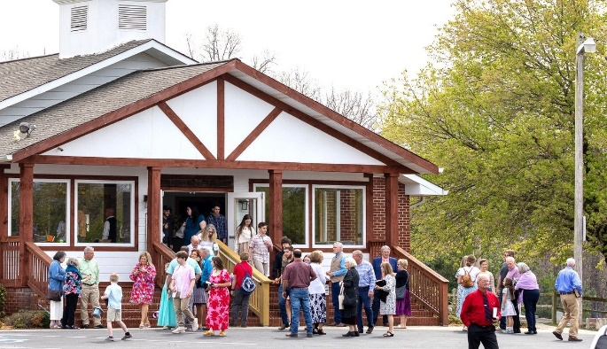
Welcome to Antioch!

May 12, 2024

Sunday

9:45 am - Sunday School
11:00 am - Worship Service

Wednesday

6:00 - 7:30 pm - Nursery
6:00 - 7:30 pm - AWANA
& Worship Kidstyle
6:00 - 7:30 pm - Youth
6:00 - 7:30 pm - Adult Bible Studies



We’ve Come to Worship

Welcome/Announcements

Worship & Praise
Faithful Now
Great is Thy Faithfulness #44
Carry Your Name
Dismiss for Children's Church
Gratitude
Sermon
A Mother’s Legacy
Rev. Sean Nix

Invitation

God of Possible



* Tuesday Morning Ladies Bible Study – A new study will start on June 18th with Annie Kintz facilitating

“The Bonfire”. This study meets every Tuesday morning @ 10am in the FLC kitchen. This new study will examine what Scripture says from Genesis to Revelation. Come join us for fellowship and dive into what Scripture says.
Contact Annie @ 706-897-4564 or Donna Gurr @ 229-395-9123 to sign up.



* 183rd Homecoming – Next Sunday, May 19th, we will celebrate Antioch’s 183rd Homecoming. This will also be David & Laura Ritcey’s last Sunday with us. Come and celebrate with us and thank David & Laura for their faithful ministry here at Antioch!

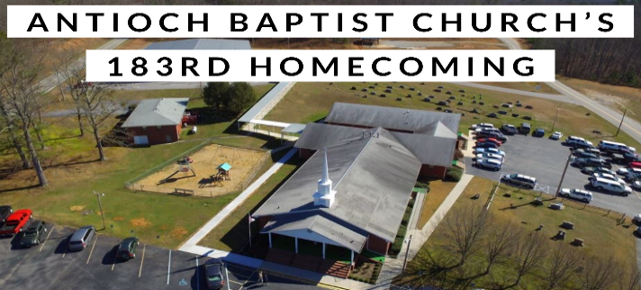

* Vacation Bible School – June 26th – 29th
This year’s theme is “Breaker Rock Beach” challenging children to be “Transformed by the renewing of your mind.” Romans 12:2. More information coming soon!
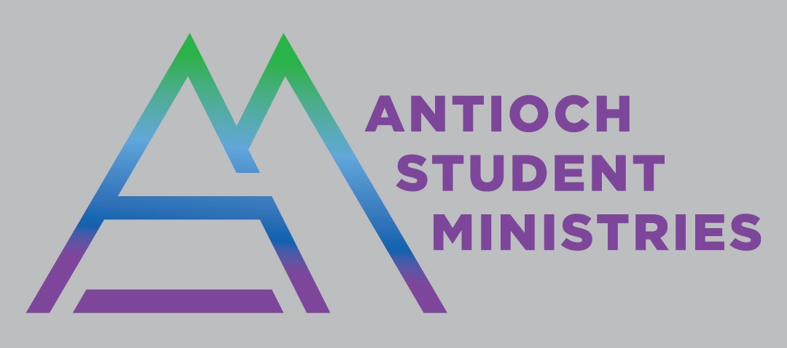

2024 High School Graduates

Zoe Dubé – Mountain Area Christian Academy
Addison Kennedy – Union County High School
Reece Manders – Union County High School
Shawn Pokrywa – Union County High School


* Men’s Ministry Breakfast meets every Monday @ 7:30am in the FLC Kitchen.

* Choir – If you are interested in joining the choir please contact Danita Kennedy for details. Practice in May will be on 5/20 from 6:30 – 8:00pm.

* Ladies Bible Studies: Join us @10am on Tuesdays, Wednesdays @6pm and @5:30pm on Thursdays in the FLC. Contact the church office for more information.

* Women On Mission - meets every 2nd Tuesday of the month @ 12:30pm in the FLC Kitchen. Mark your calendar for May 14th.

* Widows Ministry – Meets every first Thursday for lunch @ noon. Next meeting June 6th.

* Adult, Youth, & Children Activities & Bible Studies on Wednesday @ 6pm in the FLC

* Ways to Give – Drop it in the offering plates at each door, by mail, online at antiochga.org, or text “wind4350” to 888-364-4483.

